

Name | M. Ayaz Rafique
ID No | 241925
Subject | Full Stack Lab
Lab Task | 01
Date | 12th-Sept-2026

Codes Output:
Lab Task 1:
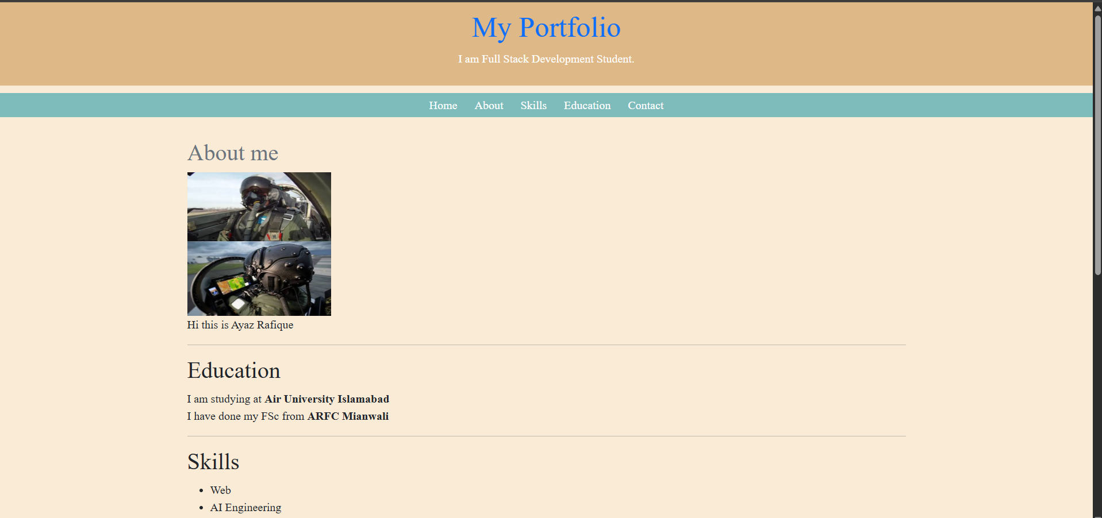
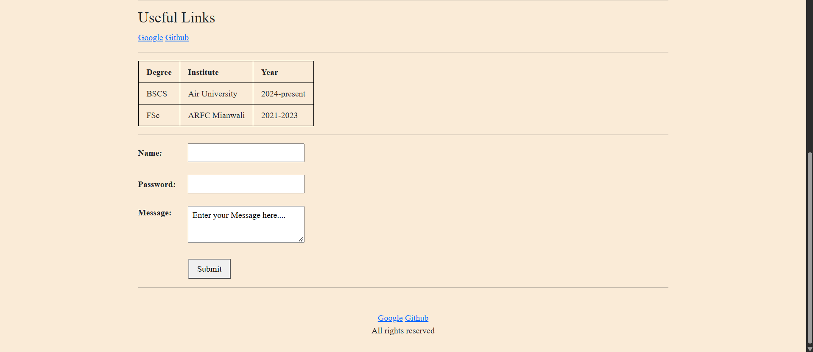

Lab Task 2: Responsive cards:
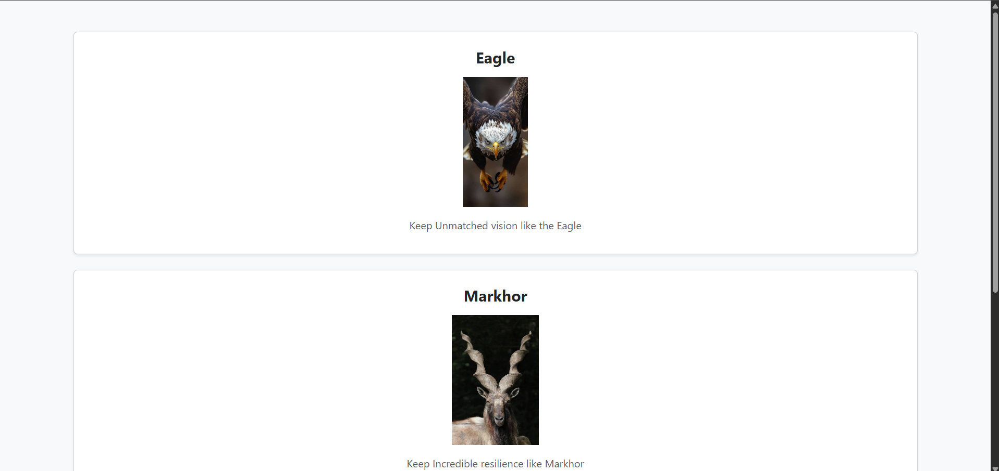

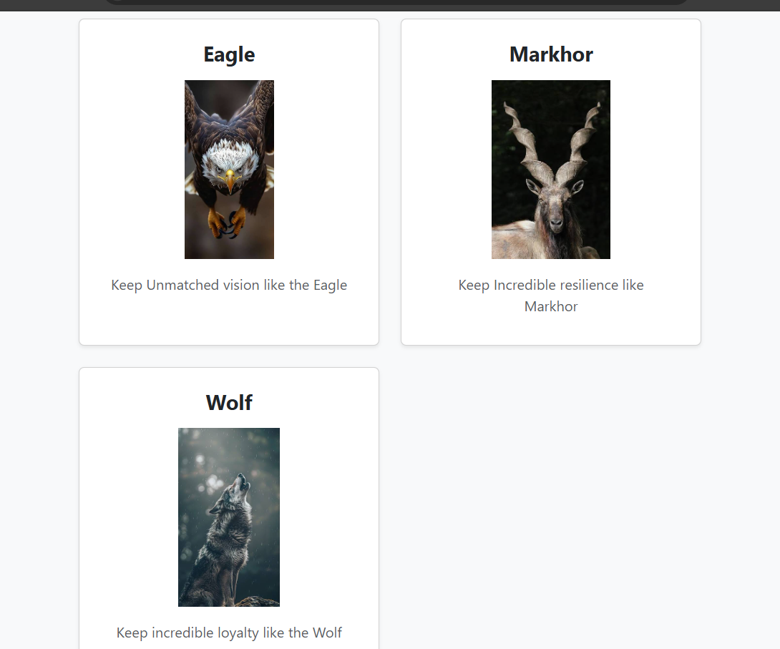
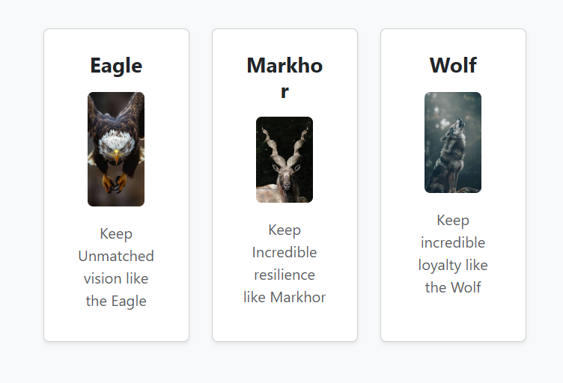

Home Task 1:


Home Task 2:
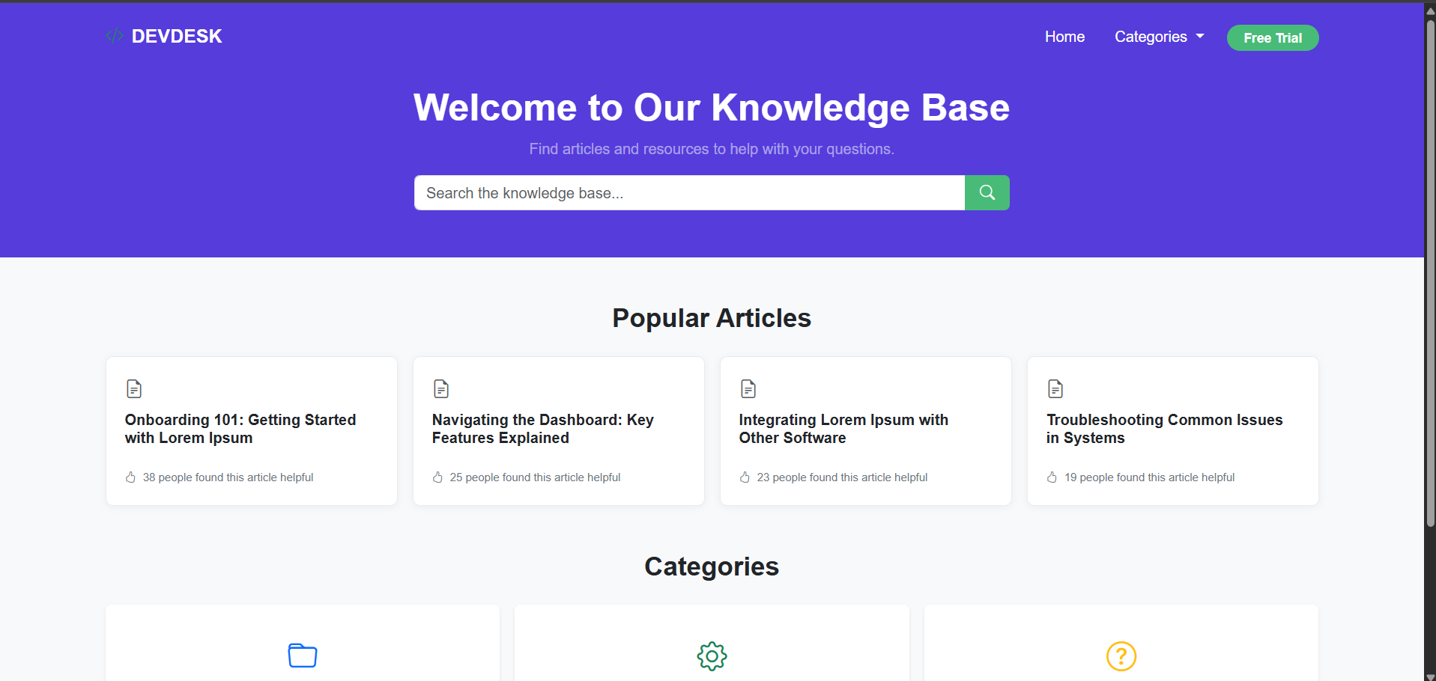


Main Operations of the Webpage
A modern web project mainly works with three important technologies: HTML, CSS, and JavaScript. HTML creates the structure of the webpage, CSS controls its design and layout, and JavaScript adds functionality and interaction. External libraries and stylesheets are also used to make the website more responsive, consistent, and user-friendly.

Structural Layout (HTML)
HTML provides the basic structure of the webpage. It is used to create important sections such as the header, navigation bar, main content, cards, and footer. It also helps organize the content properly so that search engines and screen readers can understand the webpage easily.

Responsive Layout (Grid & Layout)
The layout of the website automatically adjusts according to the user's screen size. Whether the user is using a mobile phone, tablet, laptop, or desktop, the content changes its position and size accordingly. On smaller screens, the content is usually displayed in a single column, while on larger screens, it can be arranged into multiple columns. This makes the website easier to use and prevents unnecessary horizontal scrolling.

Styling and Design (CSS)
CSS is responsible for the overall look of the website. It controls things such as colors, fonts, spacing, padding, borders, rounded corners, and card designs. It helps keep all parts of the website visually consistent and gives the project a clean and professional appearance.

Dynamic Behavior (JavaScript)
JavaScript makes the webpage interactive. It responds to actions performed by the user, such as clicking buttons, tapping on menus, or pressing keys. For example, JavaScript can be used to open a mobile menu, show popups, change image banners, display dropdowns, or close notifications.

Hover Effects and Animations
Hover effects and small animations make the website feel more interactive. When the user moves the mouse over a button or card, its appearance can change slightly. For example, a card may move up a little, its shadow may become stronger, or a button may change its color. These small effects help users understand which elements they can interact with.

3. How Everything Works Together
Component | Main Role | What It Does
HTML | Structure | Creates the basic sections, text, buttons, cards, and content.
CSS & Grid | Design & Layout | Controls colors, fonts, spacing, and makes the website responsive.
JavaScript | Functionality | Handles clicks, menus, popups, dropdowns, and other interactions.
Hover & Animation | User Experience | Adds smooth effects and makes the website feel more interactive.

4. Conclusion
Overall, all these technologies work together to create a complete and user-friendly website. HTML defines what is present on the page, CSS controls how it looks and adjusts to different screen sizes, and JavaScript controls how the website responds to the user. Hover effects and animations add a final touch that makes the website smoother and more attractive to use.

